MAY 2012 UPDATE


Thanks!
Our heartfelt thanks to everyone, for the donations of money, tinned food, clothing and bedding that have kept Harbour stocked with essentials, ready for use when needed.

Homelessness Sunday: February 5th - High Street Methodist Church
Many thanks to those who came and supported our Homelessness Sunday Lunch. It was enjoyed by all and helped to “keep up our profile” whilst raising some money at the same time.
Winter Warmth
Winter Warmth finished at the end of March, rounded off with a celebration party. Thanks to all the Volunteers who helped. It was greatly appreciated by those in need.

Harbour “Spring Clean”
Our dining and lounge area has been completely redecorated and new curtains made. It has made such a difference to the look and feel of the place. Many thanks to Elaine and Alan for all their hard work. It is much appreciated. The kitchen area will follow shortly – completing the total redecoration of the premises!

Helping our members!
Several members have been successfully re-housed since Christmas because of Harbour’s efforts. There are now only one or two of our members not in housing. This is extremely encouraging. We have also provided furniture for many of our members. Please let us know if you have any suitable items – and also if you know of any suitable places for storage!
Help with form-filling is also now becoming a regular requirement at the centre.
Annual General Meeting

Our AGM is on June 28th in St Mary’s Church at 7:30pm. There will be a brief business meeting, guest speaker and refreshments! Do come!

100 Club
Our 100 Club is now up and running. It costs £12 per year (£1 a month) and is an excellent way of raising money. Prizes are given out each month – see our website for recent winners! Contact Sue Beer at Harbour for information on how to join.
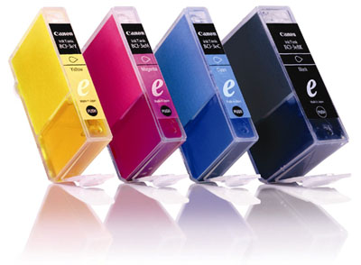
Reminder: Printer Cartridge Recycling
We have so far raised £56.75 from recycling empty ink cartridges and toners!! If you have any please drop them in to 7 Queen Street (suitably wrapped). Thank you!

Raise funds every time you search the web.
Remember to use www.easysearch.org.uk instead of your usual search engine (enter Harbour Bideford as your chosen charity) and every time you search, money is accredited to Harbour! If you buy online you can also raise money by registering on Easyfundraiser and making Harbour your nominated charity – this works with Argos, Tesco, Sainsburys, M&S and many more!

