SEPTEMBER 2011 UPDATE

Thanks!
As always, our heartfelt thanks to everyone, for the bags of tins, clothing and bedding that keep Harbour stocked with essentials, ready for use when needed. With the winter approaching we will be needing warm and waterproof clothing.

Winter Warmth
We are planning to open from 2 till 4 on Saturdays and Sundays through the winter to provide a drink and a sandwich and warmth and company. We shall need more volunteers for this – can you or anyone you know help? Please get in touch if you can.
News from the AGM
We now have two new Trustees, Anne Barrett and Andrew Hedden, AND a secretary, Anthony Chambers.
Please Support
We still have tickets to sell for the Rotary Mega-Draw. We get to keep whatever we raise! Could you help by selling a book of 5 tickets at £1 per ticket? Contact the Harbour office

Sponsored Walk
Councillor Pauline Davies is organising a Sponsored Walk by TDC, Devon and Bideford Town Councillors and Staff and even our local MP on Saturday 24th September starting at 10:00 from Bideford Station along the Tarka Trail to Instow and back in aid of homeless people. Please come along to support them.

ASDA Charity Initiative
Asda have said they will include Harbour in their new charity initiative – but there has been a delay, so please keep your eyes open for boards in Asda foyer!
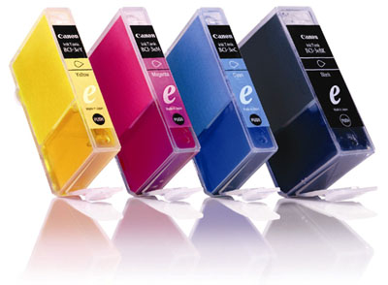
Printer Cartridge Collection
We can now recycle (at a profit) your empty ink cartridges and toners!! Please drop them in to 7 Queen Street (suitably wrapped). Thank you!

Looking Ahead
After an amazing festive event last year we aim to open again on Christmas Day.
Homelessness Sunday Lunch will be on February 5th 2012 – book this date in your diary!

